Compiled by Roger Pfister http://RogerPf.com/aaBridge

How to – Memorize Suit Distributions

This is a "How to" - if you want to read about How to practice using your new knowledge then see the next page. Here and now we focus on the, "How to".

The most efficient way to do this is to learn them like you learnt your "times tables".
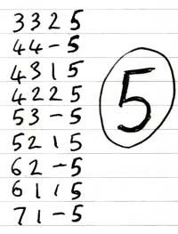
A table consists of a list of four numbers last of which is the anchor number. On the right you can see the handwritten table for the number five (5).

The widely accepted rules are do not bother with suit lengths above seven (7).

A good way of laying out these tables is to start with the lowest number possible and then to the right of it and the next highest number possible but not higher than the first so the first line of the "fives" table is 3 3 2 5

The idea is that you end up learning a group of numbers for which the missing number is in this case five. Tests have shown that it doesn't matter so much the order of the first three numbers the human brain can shuffle them around. So for example, if you know from the bidding that partner has 4 of a suit and you have 3 and dummy goes down with a singleton then the number 5 should pop into your head without effort. 4 3 1 5 You will just "know" Declarer has 5.

In a 15 minute session (1 session a day) write out the same table 3 times

Physically writing it out by hand radically strengthens memory.

When you are in the car on a long journey try to recreate it in your head. I'm not saying you have to chant it out loud like a Buddhist monk. (But it will help).

There are only eight tables, (anchor numbers) Void – Seven. Pick a new table every day and write it out 3 times. In eight days you will, as the adverts say, really notice the difference.

In just one month you have enough time to get through each table 3 time (3 x 8 = 24).

aaBridge and its Distribution Learning tools

aaBridge available free from http://RogerPf.com/aaBridge includes two tools that were developed specifically to help memorising and using the suit distributions.

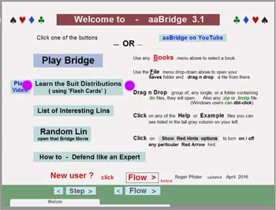
There is a YouTube video showing them in action.

https://www.youtube.com/watch?v=8xWEyuyViF8

Or you can click on the link to the video the aaBridge Welcome page.

On aaBridge click Learn the Suit Distributions button.

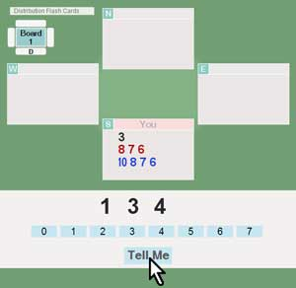
You will see something like the screen on the left. There are number of settings by which you can control exactly what is shown to you (these are not shown here but are shown in the video).

Basically you look at the screen and then work out or hopefully instantly know the missing number. You can click on the correct answer or click the Tell Me button.

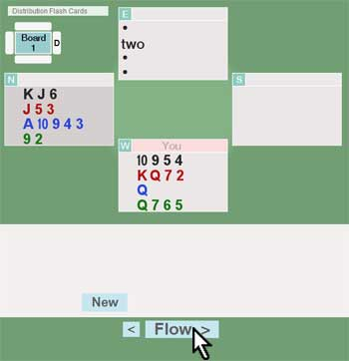
The more advanced "Exam" mode mimics a actual Bridge table. And supplies you with length information from which you can calculate a declarer's length.

It's all clearly demonstrated in the video (see earlier)
You can get, the free, aaBridge from

http://RogerPf.com/aaBridge

Suit Distributions Tabulated (courtesy of Carlyn Gauen)
Five  3 3 2 5  4 4 – 5  4 3 1 5  4 2 2 5  5 3 – 5  5 2 1 5  6 2 – 5  6 1 1 5  7 1 – 5 | Four  3 3 3 4  4 4 1 4  4 3 2 4  5 4 – 4  5 3 1 4  5 2 2 4  6 3 – 4  6 2 1 4  7 2 – 4  7 1 1 4 | Three  4 4 2 3  4 3 3 3  5 5 – 3  5 4 1 3  5 3 2 3  6 4 – 3  6 3 1 3  6 2 2 3  7 3 – 3  7 2 1 3
Six  3 3 1 6  3 2 2 6  4 3 – 6  4 2 1 6  5 2 – 6  5 1 1 6  6 1 – 6  7 – – 6 | Seven  2 2 2 7  3 3 – 7  3 2 1 7  4 2 – 7  4 1 1 7  5 1 – 7  6 – – 7
Two  4 4 3 2  5 5 1 2  5 4 2 2  5 3 3 2  6 5 – 2  6 4 1 2  6 3 2 2  7 4 – 2  7 3 1 2  7 2 2 2 | One  4 4 4 1  5 5 2 1  5 4 3 1  6 6 – 1  6 5 1 1  6 4 2 1  6 3 3 1  7 5 – 1  7 4 1 1  7 3 2 1 | Void  5 5 3 –  5 4 4 –  6 6 1 –  6 5 2 –  6 4 3 –  7 6 – –  7 5 1 –  7 4 2 –  7 3 3 –

Please write them out by hand yourself . <end of document>

